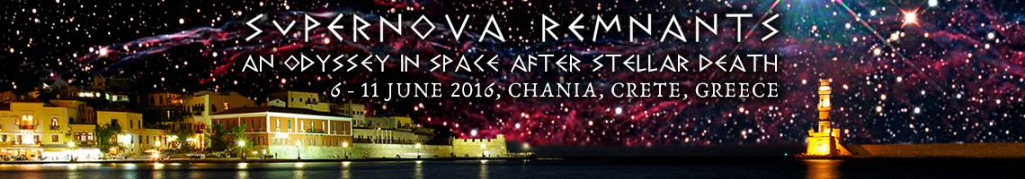

Excursion 2: Cruise to Gramvousa & Balos
Order Form
Deadline: Friday, April 08, 2016 09:00 GMT

Date: _________________
Name: ________________________________________________
Institution: _____________________________________________
E-mail: ________________________________________________

Accompanying person
_______________________________________________________
_______________________________________________________
_______________________________________________________
_______________________________________________________
_______________________________________________________

Unit Cost | Quantity
35 EUR
GRAND TOTAL

By signing this form, I commit to paying ________ EUR in cash upon registration at the meeting.

Signature:

